Name _____________________________________________________________________________
-ug word family
Directions: Choose a bug. Color it appropriately. Write the word for the picture that is on the bug. All words will end with -ug.

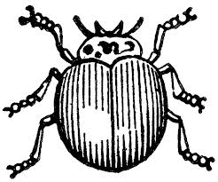
- __________________________ 4. ___________________________

- ___________________________ 5. ___________________________

- ___________________________ 6. ___________________________

Choose 1 –ug word and write a sentence.
__________________________________________________________________________________
__________________________________________________________________________________

